**Как связаны здоровье и долголетие?**

________________________________________________________________________________________________________________________________________________________________________________________________________________________________________________________________________________________________________________________________________________________________________________________________________________________________________________________**__**

**Основные составляющие здорового образа жизни**

________________________________________________________________________________________________________________________________________________________________________________________________________________________________________________________________________________________________________________________________________________________________________________________________________________________________________________________

**Здоровье современных детей**

________________________________________________________________________________________________________________________________________________________________________________________________________________________________________________________________________________________________________________________________________________________________________________________________________________________________________________________

**Здоровый образ жизни**

*Памятка для детей*

*и их родителей*

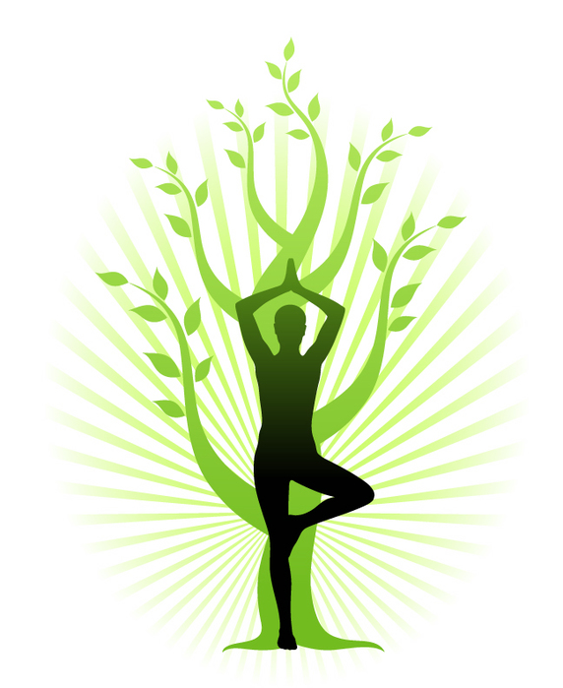

**Зачем нам здоровье?**

______________________________________________________________________________________________________________________________________________________________________________________________________Автор памятки: __________________________________________________________________

***Интересные факты о здоровье и здоровом образе жизни***

________________________________________________________________________________________________________________________________________________________________________________________________________________________________________________________________________________________________________________________________________________________________________________________________________________________________________________________